

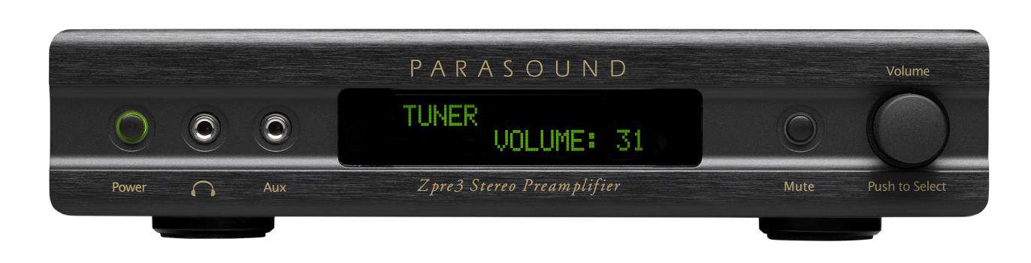


Parasound’s new Zpre3 stereo preamp builds on the success of its predecessor

Parasound Products Inc. San Francisco, CA USA, 6th October 2016.
Parasound’s new Zpre3 boasts a compact size, audiophile performance and an array of useful custom integration features that makes the Zpre3 suitable for just about any audio system.
Arguably a compact stereo preamplifier the Zpre3 is packed with custom integration features and the audiophile level of performance that Parasound is known for. There are five audio line level inputs including a front panel Aux input and a Bypass input and each can be renamed to identify the connected source. The Bypass input enables integration with audio sources that have their own volume controls, such as AV receivers and streaming devices like the Sonos Connect, Heos Link, BlueSound Node, Google Chromecast Audio or Apple Airport Express. The Bypass input is automatically selected when the Zpre3 is powered off, so users can listen to their streaming devices without having to turn on the Zpre3.

The Zpre3 has features specifically for the professional custom installation market, including discrete IR remote commands, a 12V trigger output and 2-way RS232 with direct volume control. Automatic RS232 feedback allows for easy integration with keypads and touch-screen control systems such as Crestron®, RTI®, AMX®, Control4®, Savant®, and Elan®. Additional features include both automatic turn on volume memory and favorite volume memory, so it’s easy for the user to jump to his or her most common listening levels. There are fixed and variable outputs, as well as separate Mono outputs for a subwoofer and for architectural speakers.
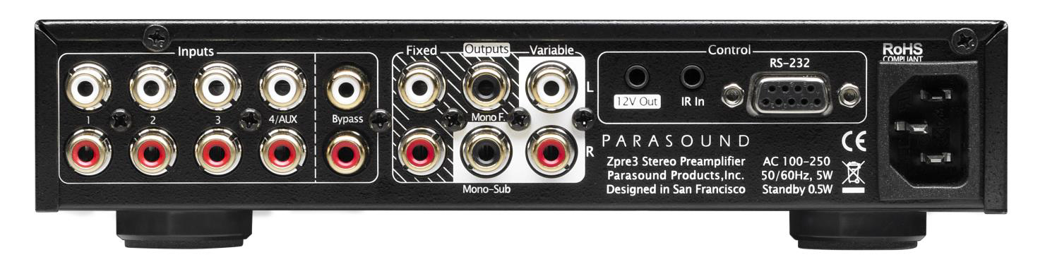
Features:
- Front panel dimmable LCD display
- Automatic turn on volume memory
- Favorite volume memory with remote control button
- 2-way RS232 w/ exact volume control & feedback
- Discrete commands for all functions
- Rename inputs to match connected source
- 5 audio inputs including a front panel Aux input
- Bypass input integrates easily w/ a Sonos Connect® etc.
- Bass, treble and balance adjustments by remote control
- Variable and fixed stereo outputs
- Variable and fixed mono/subwoofer outputs
- 12V trigger output and rear panel IR input

Specifications:
Frequency Response: 10 Hz to 40 kHz (+0 / -0.5 dB)
THD: < 0.015 % (20 Hz to 20 kHz)
Input Sensitivity: Total gain = 12 dB (volume set to 100)
S/N Ratio: > 100 dB (A-weighted), > 90 dB (un-weighted)
Dimensions:
Width: 8.5” (220 mm)
Depth: 10” (254 mm) or 12” (305 mm) w/ cables
Height: 2” (51 mm) or 1.75” (45 mm) 1U w/ out feet
Weight: Net 4.0 lbs. (1.8kg), Shipping 7.0 lbs. (3.1 kg)

What has changed from the Zpre2 ?
- Front panel LCD display
- RS232 w/ exact volume control & feedback
- Bass, treble & balanced control by remote
- Automatic turn on volume memory
- Favorite volume memory
- Bypass input and front panel Aux input
- Subwoofer and mono outputs

The new Zpre3 compact stereo preamp is available in black in the UK from November 2016 at a retail price inc VAT of £499

For more sales information on Parasound products in the UK please contact: Connected Distribution on 01242 511133 www.connecteddistribution.com

More information and high-resolution photographs are available by contacting:
Neil Truckell, IOS Company (UK) Limited: Office: 01249 708641 / Mobile: 07971 634239 / Email: neil@ioscompany.co.uk
Or: Ric Stevenson, RSPR Limited: Office: 01797 260882 / Mobile: 07974 926157 / Email: richard@rspr.co.uk

About PARASOUND
Founded in 1981, Parasound Products, Inc. is a privately owned U.S. company that specializes in providing award winning yet affordable high quality audio and home theatre components to music and movie enthusiasts in over 60 countries. As well as its long pedigree in the home audio and home theatre sectors it also has long-standing relationships in music recording and film studios, where many mixers, producers and sound designers rely on Parasound for sonic accuracy and dependability - and often choosing Parasound over much more expensive brands. Parasound is a company where every customer matters and we don’t think you’ll find a company more dedicated to its craft and to your success.

About AV Distributors BV
AV Distributors BV, based in the Netherlands, was formed in 2012 specifically to take care of Parasound’s sales, logistics, marketing and service in Europe, the Middle East and Africa. Although the company name is new, the team at ‘AVD’ has decades of experience with Parasound and prides itself on extensive product knowledge, customer service focus and ‘easy to do business with’ attitude.

*Sonos Connect®, Heos Link®, BlueSound Node®, Google Chromecast Audio® and Apple Airport Express® are registered trademarks of their respective owners.

